

**‘**Large Mammal Community Structure in Peri-Urban Forest Landscapes’

**Master-Thesis**

**prepared at the Faculty of Natural Sciences I (Biosciences),**

**Institute of Biology of the**

****Martin Luther University Halle-Wittenberg****

**in cooperation with the Center for Integrative Biodiversity Research Halle-Jena-Leipzig (iDiv)**

**research group ‘**Biodiversity and Conservation**’ lead by**

****Prof. Henrique Miguel Pereira****

**and under supervision of**

**Dr. Néstor Fernández**

**for the award of the academic degree**

**Master of Science (Biology) (M.Sc. Biology, 120 credit points)**

**submitted by**

**Nils Gmyrek - Matriculation number: 214 210 547**

**Born on 31.03.1993 in Bad Nauheim**

**Reviewer:**

**Reviewer:**

**Submitted on:**

**Table of Content**

Introduction 2

Methods 4

Study Region 4

Study Design 5

Camera Trap Deployment 5

Image Processing with Megadetector AI on the EVE Cluster 6

Manual Labeling with Agouti 6

Results 7

Image Processing Outcomes 7

Confusion Matrix and Accuracy Evaluation 7

Confusion Matrix (Sample Size: 1000) 7

Confusion Matrix (Sample Size: 3000) 7

Accuracy Probabilities (Sample Size: 1000) 8

Accuracy Probabilities (Sample Size: 3000) 8

Discussion 9

Conclusion 9

References 9

Eidesstattliche Erklärung 15

Appendix 17

Appendix X 17

Bescheinigung über das Nicht-Bestehen von Verbindlichkeiten 17

Digital Appedix 18

# Introduction

The rapid migration of humans into urban areas in the 21st century (Forman, 2014; Gaston, 2014) has resulted in an unprecedented shift in global population dynamics, with the urban population project to increase to 60% by 2023 (Knorr et al., 2018). For the first time in history, the majority of the world’s population resides in cities, with urban dwellers already exceeding 80% in developed regions such as North America (United Nations, 2014). This urbanization has turned cities into hotspots of anthropogenic effects on ecosystems, leading to increased rates of species extinction (Czech et al., 2000), a higher prevalence of invasive and exotic species (Riley et al., 2003), and a growing psychological disconnect between people and nature (Miller, 2005).

The increasing demands of a growing human population for food and living space are driving the transformation of natural habitats into human-dominated landscapes (Mulwa et al., 2012). This shift places immense pressure on natural resources and intensifies the conflict between the goals of productivity and conservation (Margules & Pressey, 2000). Such conversions lead to the loss, fragmentation, and degradation of habitats, all of which have well-documented adverse impacts on biodiversity across various biomes and species. For instance, Fahrig (2003) highlights that habitat fragmentation reduces biodiversity by isolating populations and increasing their vulnerability to stochastic events. Similarly, Vie et al. (2009) report widespread declines in species populations and diversity as a direct result of these anthropogenic changes. The Secretariat of the Convention on Biological Diversity (2010) and Hoffmann et al. (2010) also emphasize the global scale of biodiversity loss driven by habitat modification.

These transformations are particularly harmful because they disrupt the continuity of ecosystems and the availability of habitat for wildlife. Habitat loss occurs when large, contiguous areas of natural habitat are cleared for agriculture, urban development, or other uses, reducing the overall space available for wildlife. Fragmentation further compounds this problem by breaking up the remaining habitat into smaller, isolated patches. According to Island biogeography theory, proposed by MacArthur and E.O. Wilson (1963), the number of species in an isolated habitat results from a balance between immigration rates and extinction rates. Larger patches support more species due to higher immigration and lower extinction rates, while smaller patches experience more local extinctions. The theory also suggests that isolated patches, like islands, are more vulnerable due to reduced immigration from other areas. These patches may be too small to support viable populations of many species, leading to local extinctions (Reed, 2004). Additionally, the edges of these fragments often experience different environmental conditions than the interior, further degrading habitat quality (Laurance et al., 2007).

Degradation involves the decline in the quality of the habitat that remains. Pollution, invasive species, and changes in land management practices can all contribute to this decline, making the environment less suitable for native species (Piola & Johnston, 2008). These processes not only reduce the number of species that an area can support but also impact the ecological functions that these species provide, leading to broader ecosystem instability (Hanski, 2011).

Especially, large mammals play crucial roles in shaping ecosystems as 'ecological landscapers' by modifying vegetation structure, altering nutrient pathways, and influencing biodiversity (Sinclair, 2003). They perform various ecological functions, including herbivory, seed dispersal, predation, and ecosystem engineering (Lacher et al., 2019). The loss of large mammals can have cascading effects on ecosystem structure and function. Currently, about 60% of the world's largest terrestrial herbivores are threatened with extinction, primarily due to hunting, land-use change, and competition with livestock in developing countries (Ripple et al., 2015). This ongoing decline of large mammals is expected to have far-reaching consequences for ecosystems and human societies (Malhi et al., 2016; Ripple et al., 2015).

Urban environments, characterized by high population densities and extensive infrastructure, significantly disrupt natural habitats (Grimm et al., 2008; Pickett et al., 2001). The intense human activity in these areas leads to habitat fragmentation and alteration, causing changes in species composition and community structure (Bateman & Fleming, 2012; Blair, 1996). Urban development increases human-wildlife conflict (McKinney, 2006), brings domestic animals into closer contact with wildlife (Luniak, 2004), introduces noise pollution, and creates physical barriers like fences and roads (Newport et al., 2014).

Agricultural landscapes also impact wildlife, presenting different challenges depending on the type and intensity of farming practices (Gerard & Service, 1995). Habitat availability and its distribution across the land use matrix significantly influence the occupancy of a habitat patch (Ramesh et al., 2016). Forests, which house most of the world’s terrestrial species (Pillay et al., 2022), are particularly affected by fragmentation. This fragmentation increases the amount of forest edge (edge effects) and reduces the amount of interior forest, where most species reside (Laurance et al., 2011). Taubert et al. (2018) identified over 130 million forest fragments across subtropical and tropical regions, finding that more than 70% of the world’s remaining forests are less than 1 km from the nearest edge, and 20% are less than 100 m from the nearest edge (Haddad et al., 2015). Proximity to a forest edge creates numerous negative ecological effects on biodiversity (Laurance et al., 2011, 2018).

Forests provide a range of ecosystem services including habitat, timber, carbon storage, water quality, recreation, and amenity. However, due to their market value, forest goods, particularly wood, have been in higher demand than other benefits provided by forests, such as soil stability (Liu & Diamond, 2005), climate regulation (Malhi et al., 2009), and biodiversity (Barlow et al., 2007). This bias has led to the loss and fragmentation of native forests and the establishment of monoculture plantations, which do not promote biodiversity (Hartley, 2002). Production forests with low biodiversity are more vulnerable to disturbance and environmental change than natural forests (Carnus et al., 2006; Lugo, 1997).

In a world facing rapid environmental changes, the role of forest ecosystems in conservation, as reservoirs of biodiversity and providers of multiple ecosystem services, is of unquestionable importance (Shvidenko et al., 2005). Recent forecasts indicate that land use change will remain the main cause of biodiversity loss in the coming decades (van Vuuren et al., 2006).

Despite the wealth of research on habitat loss and fragmentation, there remains a significant gap in understanding how these processes affect mammal communities in both urban and agricultural landscapes. Few studies have comprehensively examined the combined effects of land use, patch size, and connectivity on mammal populations. Moreover, large mammals, which are crucial for ecosystem health, are often overlooked in research, leaving a gap in knowledge about how these species respond to human-induced habitat changes (citation).

While significant progress has been made in understanding the impacts of habitat loss and fragmentation on biodiversity, there are several areas that remain underexplored, particularly regarding the interactions between land use, habitat connectivity, and species diversity. Existing research has predominantly focused on either urban or agricultural landscapes in isolation, often overlooking the complex interplay between these land uses and their cumulative effects on wildlife communities (McKinney, 2002; Gerard & Service, 1995).

This study addresses these gaps by employing a camera trap survey across multiple fragmented forest patches in both urban and agricultural settings. This approach allows for the collection of data on mammal species diversity and occupancy, offering insights into the differential impacts of land use change on wildlife communities. By assessing variations in patch size and connectivity, the study will help elucidate how these factors interact to influence mammal populations.

In urban environments, the effects of habitat fragmentation are well-documented, yet there is limited understanding of how varying levels of urbanization influence mammal communities specifically within fragmented forest patches. Similarly, while agricultural landscapes have been studied extensively, research often fails to account for the influence of different agricultural practices and their interaction with habitat fragmentation on mammal populations (Ramesh et al., 2016).

Moreover, the combined effects of patch size and connectivity on mammal communities in both urban and agricultural settings have not been thoroughly investigated. For instance, while habitat edges and their associated effects on biodiversity are well established (Laurance et al., 2007), the specific impact of edge effects in urban versus agricultural contexts, and how these may vary depending on patch size and connectivity, remains unclear.

Additionally, there is a lack of comprehensive studies that integrate the effects of land use change with an assessment of species-specific responses to fragmentation. Large mammals, which play crucial ecological roles, are particularly underrepresented in these studies, despite their significant contribution to ecosystem functions and services (Sinclair, 2003; Ripple et al., 2015).

This study aims to fill these gaps by investigating how variations in patch size, connectivity, and land use influence mammal communities across both urban and agricultural landscapes. By conducting a camera trap survey across different forest fragments, this research will provide new insights into the differential impacts of urbanization and agricultural practices on wildlife, enhancing our understanding of how to mitigate biodiversity loss in human-dominated landscapes. These insights are crucial for developing targeted conservation strategies that address the complex challenges posed by modern land use changes.

Our hypotheses are that mammal communities in urban areas will differ significantly from those in agricultural landscapes due to the varying environmental conditions and levels of human influence (McKinney, 2002). Additionally, we expect higher forest fragmentation to be associated with lower species diversity due to the negative impacts of habitat loss and increased human disturbance (Fahrig, 2003; Haddad et al., 2015). By addressing these questions, this study aims to contribute to the broader understanding of how human-dominated landscapes affect mammal communities. The findings will inform strategies for conserving biodiversity in urban and agricultural areas, aiding in the creation of more wildlife-friendly cities and sustainable farming practices.

The findings of this research will provide valuable insights into how urbanization and agricultural practices shape mammal communities, aiding in the development of targeted conservation strategies. These strategies are essential for mitigating biodiversity loss, promoting wildlife-friendly urban environments, and advancing sustainable farming practices that support both productivity and biodiversity conservation. Ultimately, this study aims to inform the design of more resilient landscapes that accommodate both human needs and wildlife conservation.

# Methods

## Study Design

The study was conducted within a 20 km radius of Leipzig Hauptbahnhof, focusing on forest patches managed by Sachsenforst, Stadtforsten, and a privately owned forest managed by Forstbetrieb Müller. To delineate continuous forest patches, we used data from ATKIS (Amtliches Topographisch-Kartographisches Informationssystem), which allowed us to identify patches of forest divided by barriers such as railways, roads, and large rivers. Streams were excluded from this classification as we assumend they do not significantly impact wildlife movement. The forest patches were selected based on their size, connectivity, and the surrounding land use matrix. Patches were considered continuous if they were uninterrupted by significant barriers, ensuring they function as coherent ecological units. This approach aligns with established ecological principles suggesting that the number of species in a given area increases with the area size, as described by the power law model provided by Dengler (2009):

S(A)=cAz

This approach aligns with established ecological principles that suggest the number of species in a given area increases as the area size expands, a concept first proposed by Arrhenius in 1921. Various mathematical models, including the power law, have been developed to quantify this relationship. The exponent z in this equation depends on the sampling method and scale used, influencing how species richness scales with increasing area. On the other hand, the constant c varies according to the specific taxonomic group and geographic region, representing the baseline species richness per unit area (Rosenzweig, 1995).

For our study, we selected values of c=1 and z=0.25 in the power law model based on established ecological patterns and the specific objectives. The exponent z, which reflects how species richness increases with area size, was set at 0.25. This value is well-supported in the literature (Rosenzweig, 1995), particularly in studies of terrestrial ecosystems and fragmented landscapes, where moderate increases in area yield predictable increases in species richness. By using z=0.25, we align with the standard rate of species accumulation observed in forest patches of comparable size and habitat conditions.

The constant c, which represents the baseline number of species per unit area, was set at 1 to simplify interpretation and standardize the initial estimate of species richness. This assumption aligns with the relatively moderate biodiversity expected in the forest patches of the Leipzig area, providing a consistent starting point for comparing species richness across different patches. Overall, these parameter choices allow for a meaningful analysis of the species-area relationship in the context of the fragmented forest habitats surveyed, facilitating insights into biodiversity patterns and the effects of patch size and connectivity on mammal communities.

#### Table 1: Summary of Forest Patches and their Number of Camera Trap Stations

|  |  |  |  |  |
| --- | --- | --- | --- | --- |
| Patch_ID | Responsibility | Habitat Type | Area in km2 | CT |
| LE0001 | Sachsenforst | agriculture | 1.31518516405302 | 3 |
| LE0002 | both | agriculture | 0.433376239909493 | 2 |
| LE0003 | Sachsenforst | agriculture | 0.168833612708904 | 2 |
| LE0006 | Stadtforsten | agriculture | 0.0342710869606175 | 1 |
| LE0007 | Stadtforsten | agriculture | 0.159148870530854 | 1 |
| LE0012 | Stadtforsten | agriculture | 0.0520803023770796 | 1 |
| LE0013 | Stadtforsten | agriculture | 0.0354201678344309 | 1 |
| LE0014 | Stadtforsten | agriculture | 0.0821443119048014 | 1 |
| LE0017 | Sachsenforst | agriculture | 0.560958541451312 | 1 |
| LE0018 | Stadtforsten | urban | 0.0644218639995641 | 1 |
| LE0020 | Stadtforsten | urban | 0.098443135451531 | 1 |
| LE0021 | Stadtforsten | urban | 0.0842432349333595 | 1 |
| LE0022 | Stadtforsten | urban | 0.338844862322702 | 2 |
| LE0023 | Stadtforsten | urban | 1.74580318962494 | 3 |
| LE0024 | Stadtforsten | urban | 0.572378558739638 | 2 |
| LE0025 | Stadtforsten | urban | 0.419484862329839 | 2 |
| LE0028 | Stadtforsten | urban | 0.115178725945205 | 1 |
| LE0029 | Stadtforsten | urban | 0.120434970147752 | 1 |
| LE0030 | Stadtforsten | urban | 0.208504391729782 | 2 |
| LE0037 | ForstMueller | agriculture | 3.30706662264195 | 4 |
| LE0038 | Stadtforsten | urban | 0.090610394807703 | 1 |
| LE0039 | Stadtforsten | urban | 1.76333334128568 | 3 |
| LE0041 | Sachsenforst | agriculture | 1.62359976383853 | 3 |
| LE0043 | Sachsenforst | agriculture | 0.480487434118445 | 2 |
| LE0044 | Stadtforsten | urban | 0.0428219635265418 | 1 |
| LE0049 | Stadtforsten | agriculture | 0.277975565514532 | 2 |
| LE0050 | Sachsenforst | agriculture | 0.222916757860252 | 2 |
| LE0053 | Stadtforsten | urban | 0.137275235712739 | 1 |
| LE0059 | Stadtforsten | agriculture | 0.564391158608873 | 2 |
| LE0063 | Stadtforsten | urban | 0.116327950840396 | 1 |
| LE0064 | Stadtforsten | agriculture | 1.4722495868549 | 3 |
| LE0066 | Stadtforsten | urban | 0.190404830379745 | 2 |
| LE0068 | both | urban | 3.00508796006756 | 4 |
| LE0070 | Sachsenforst | agriculture | 0.317533619837964 | 2 |
| LE0074 | Stadtforsten | agriculture | 0.113367231534758 | 1 |
| LE0034 | Stadtforsten | urban | 0.304364408629466 | 2 |
| LE0075 | Stadtforsten | urban | 0.1346788643067 | 1 |
| LE0035 | Stadtforsten | urban | 0.486078933619062 | 2 |
| LE0078 | Stadtforsten | urban | 0.0803016392365015 | 1 |
| LE0081 | Stadtforsten | agriculture | 0.0423698330458486 | 1 |
| LE0082 | Stadtforsten | urban | 0.150050355503014 | 1 |
| LE0065 | Sachsenforst | agriculture | 5.56023442599032 | 4 |

#### Map 1: Sampled Forest Patches and Camera Trap Stations (black dots) in and around Leipzig (Saxony) in Germany.

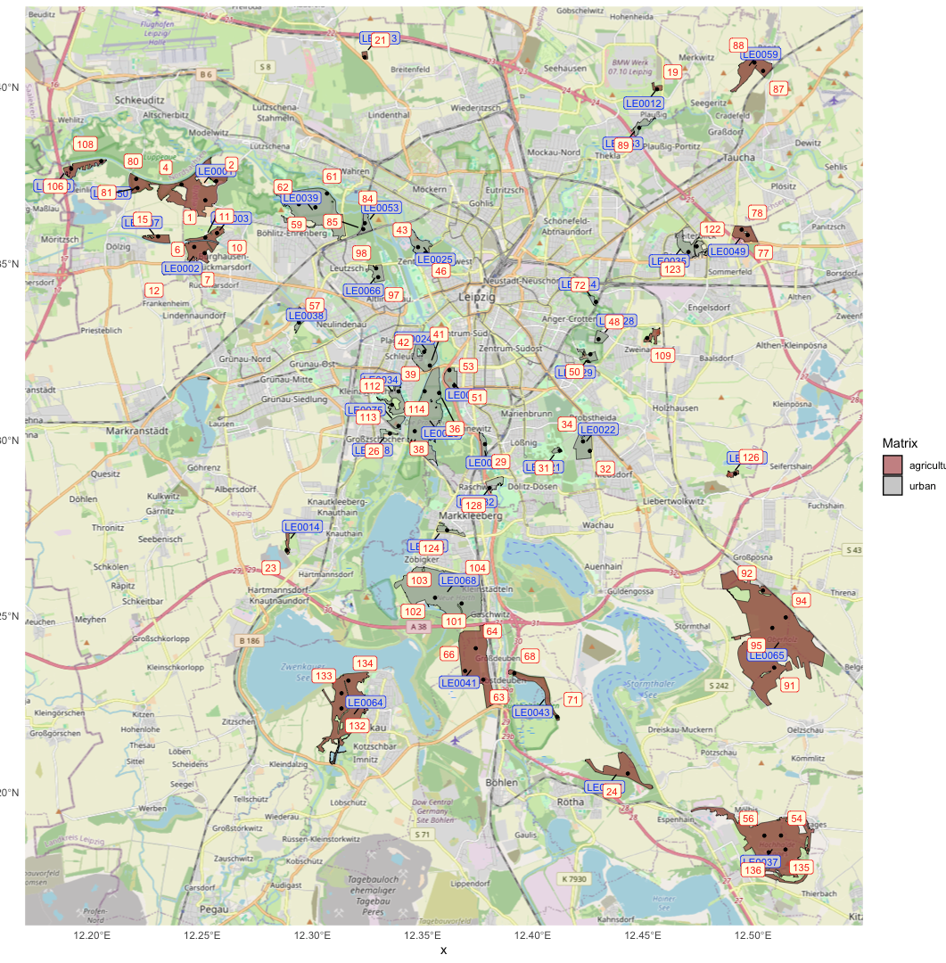

## Camera Trap Deployment

To comprehensively monitor wildlife across the selected forest patches, a total of 75 camera traps were deployed from February 20, 2024, to April 29, 2024. To gather data on mammal communities within these forest patches, single Camera-Trap Stations were established through random point sampling. Suitable locations for these Camera-Trap Stations were identified within a 30-meter radius of each random point. This approach ensured that sampling stations were placed in representative areas of the forest patches while minimizing bias introduced by external factors. These traps were set up using Browning Elite HP5 SPECOPS BTC-BE-HP5 models, which were configured to operate in TRAIL CAM mode. This setting allowed the cameras to capture still images of wildlife both during the day and at night, focusing particularly on trails and feeding areas.

During deployment, detailed notes were made on each camera's location, the date and time of deployment, the number of the camera trap (000 - 080), key number of the lock, the height at which the camera was positioned, and the initial battery status in percent. The cameras were set to capture images with a resolution of 12 megapixels, with a 5-second delay between each capture. They were programmed to use the Rapid-Fire 3 Shots mode, taking three consecutive images with only a 0.3-second interval between shots. Temperature was recorded in Celsius, with motion detection extending to a range of 100 feet (30.48 meters) and a fast trigger speed of 0.1 seconds. The cameras operated continuously, capturing images 24 hours a day.

Upon retrieval, notes were taken on the date and time of collection, whether any cameras had been stolen, and the total number of photos each camera had captured. Despite the extensive deployment, two cameras were unfortunately lost or stolen. By the end of the data collection period, the remaining cameras had captured a total of 284 988 images. Due to the substantial volume of data, an automated image processing system was employed to categorize and analyze the images efficiently.

#### Table 1: Summary of Deployment Data

|  |  |  |  |  |  |  |  |  |  |
| --- | --- | --- | --- | --- | --- | --- | --- | --- | --- |
| Point_ID | PatchID | Date | Time | Heights (cm) | Latitude | Longitude | Retrieve Date | Retrive Time | Photos |
| 56 | LE0037 | 20.02.24 | 12:34 | 43 | 51.1875182640868 | 12.5051327009546 | 08.04.24 | 15:25 | 303 |
| 54 | LE0037 | 20.02.24 | 13:28 | 43 | 51.1875612023932 | 12.5126916904729 | 08.04.24 | 15:46 | 1518 |
| 135 | LE0037 | 20.02.24 | 14:19 | 42 | 51.1835909156211 | 12.5147266654916 | 08.04.24 | 16:08 | 2169 |
| 136 | LE0037 | 20.02.24 | 15:16 | 42 | 51.1827967502042 | 12.507129126501 | 08.04.24 | 16:42 | 19524 |
| 24 | LE0017 | 20.02.24 | 17:45 | 41 | 51.2051942769946 | 12.4431743140333 | 08.04.24 | 14:52 | 553 |
| 126 | LE0081 | 21.02.24 | 11:19 | 39 | 51.2903353766467 | 12.4919382567967 | 08.04.24 | 10:15 | 2169 |
| 92 | LE0065 | 21.02.24 | 13:08 | 44 | 51.2572296003437 | 12.5045185385555 | 08.04.24 | 12:01 | 49 |
| 94 | LE0065 | 21.02.24 | 14:13 | 37 | 51.2495703407887 | 12.5148493645937 | 08.04.24 | 12:28 | 513 |
| 95 | LE0065 | 21.02.24 | 15:01 | 40 | 51.2465781719274 | 12.5087468771946 | 08.04.24 | 13:33 | 546 |
| 91 | LE0065 | 21.02.24 | 16:04 | 40 | 51.2353029919349 | 12.5096127698604 | 08.04.24 | 14:06 | 1245 |
| 106 | LE0070 | 22.02.24 | 11:59 | 41 | 51.3768183230119 | 12.1905440110647 | 09.04.24 | 11:07 | 1136 |
| 108 | LE0070 | 22.02.24 | 12:47 | 48 | 51.3790017584602 | 12.2042041564558 | 09.04.24 | 11:28 | 279 |
| 80 | LE0050 | 22.02.24 | 13:39 | 48 | 51.3739551332719 | 12.2200367506071 | 09.04.24 | 13:06 | 405 |
| 81 | LE0050 | 22.02.24 | 14:01 | 46 | 51.371373174417 | 12.2206259710303 | 09.04.24 | 13:23 | 402 |
| 1 | LE0001 | 22.02.24 | 15:57 | 41 | 51.3679057931621 | 12.251415632521 | 09.04.24 | 14:19 | 940 |
| 4 | LE0001 | 22.02.24 | 16:25 | 42 | 51.3723842286429 | 12.2406083345989 | 09.04.24 | 13:51 | 70 |
| 2 | LE0001 | 22.02.24 | 16:55 | 46 | 51.3733170805692 | 12.256338562541 | 09.04.24 | 14:04 | 724 |
| 6 | LE0002 | 23.02.24 | 11:52 | 48 | 51.3546821926091 | 12.246372306717 | 09.04.24 | 15:59 | 414 |
| 7 | LE0002 | 23.02.24 | 12:24 | 47 | 51.3529456629472 | 12.2511193721732 | 09.04.24 | 14:39 | 672 |
| 10 | LE0003 | 23.02.24 | 13:08 | 50 | 51.3586127740108 | 12.2567181082142 | 09.04.24 | 14:55 | 1335 |
| 11 | LE0003 | 23.02.24 | 13:57 | 39 | 51.3573682347952 | 12.2514069335149 | 09.04.24 | 15:08 | 539 |
| 15 | LE0007 | 23.02.24 | 14:28 | 43 | 51.3576578737939 | 12.2299829154835 | 09.04.24 | 15:31 | 964 |
| 12 | LE0006 | 23.02.24 | 15:17 | 47 | 51.3473721368704 | 12.2352916434401 | 09.04.24 | 16:41 | 828 |
| 57 | LE0038 | 27.02.24 | 10:59 | 49 | 51.3332470332519 | 12.293905898083 | 09.04.24 | 10:13 | 390 |
| 23 | LE0014 | 27.02.24 | 12:09 | 44 | 51.2685861869331 | 12.2883695981647 | 11.04.24 | 10:48 | 3204 |
| 26 | LE0018 | 27.02.24 | 12:59 | 70 | 51.301759787788 | 12.3351855192671 | 25.04.24 | 14:35 | 864 |
| 114 | LE0075 | 27.02.24 | 13:42 | 41 | 51.3039155018908 | 12.3390682687501 | 25.04.24 | 15:00 | 3159 |
| 132 | LE0064 | 27.02.24 | 17:30 | 48 | 51.22369618122 | 12.3132017816739 | 11.04.24 | 12:24 | 1728 |
| 133 | LE0064 | 28.02.24 | 10:33 | 47 | 51.2280258605495 | 12.3132378240663 | 11.04.24 | 12:00 | 459 |
| 134 | LE0064 | 28.02.24 | 11:17 | 42 | 51.2316125183553 | 12.31633532295 | 11.04.24 | 11:37 | 3051 |
| 64 | LE0041 | 28.02.24 | 12:17 | 46 | 51.2407914574772 | 12.3741644875795 | 12.04.24 | 12:32 | 78318 |
| 66 | LE0041 | 28.02.24 | 12:46 | 44 | 51.2343599590754 | 12.3693154604865 | 12.04.24 | 12:56 | 507 |
| 63 | LE0041 | 28.02.24 | 13:11 | 44 | 51.2318821125507 | 12.3775454386828 | 12.04.24 | 13:30 | 3264 |
| 101 | LE0068 | 28.02.24 | 13:57 | 45 | 51.2535250166162 | 12.3677329131845 | 12.04.24 | 11:59 | 660 |
| 104 | LE0068 | 28.02.24 | 14:28 | 52 | 51.2588190357275 | 12.3678181967328 | 12.04.24 | 11:42 | 6585 |
| 102 | LE0068 | 28.02.24 | 15:18 | 51 | 51.2551629682455 | 12.3556759989563 | 12.04.24 | 11:23 | 606 |
| 103 | LE0068 | 28.02.24 | 15:37 | 49 | 51.2600612937936 | 12.3584291419453 | 12.04.24 | 11:07 | 1326 |
| 124 | LE0078 | 28.02.24 | 16:14 | 56 | 51.2743148796081 | 12.3611599878175 | 12.04.24 | 10:41 | 834 |
| 128 | LE0082 | 28.02.24 | 16:49 | 44 | 51.2863201544348 | 12.3804224338335 | 17.04.24 | 12:17 | 1098 |
| 31 | LE0021 | 28.02.24 | 17:29 | 42 | 51.2969421775136 | 12.4122793948035 | 17.04.24 | 13:16 | 2388 |
| 34 | LE0022 | 28.02.24 | 17:55 | 51 | 51.299536857176 | 12.4228308251471 | 17.04.24 | 14:01 | 3753 |
| 32 | LE0022 | 28.02.24 | 18:14 | 52 | 51.296838101288 | 12.4259502002851 | 17.04.24 | 13:41 | 570 |
| 50 | LE0029 | 29.02.24 | 10:20 | 48 | 51.3242618265513 | 12.4261915231958 | 18.04.24 | 10:57 | 1626 |
| 48 | LE0028 | 29.02.24 | 10:50 | 40 | 51.3285214184163 | 12.4298762839756 | 18.04.24 | 11:16 | 2742 |
| 109 | LE0074 | 29.02.24 | 11:22 | 41 | 51.3288601104501 | 12.4519437261404 | 18.04.24 | 12:54 | 0 |
| 122 | LE0035 | 29.02.24 | 12:41 | 46 | 51.3548508593713 | 12.4744103144444 | 18.04.24 | 13:48 | 3366 |
| 123 | LE0035 | 29.02.24 | 13:02 | 50 | 51.3532497240872 | 12.4707166506827 | 18.04.24 | 14:13 | 936 |
| 78 | LE0049 | 29.02.24 | 13:47 | 41 | 51.3595885215277 | 12.4948257408227 | 11.04.24 | 14:25 | 1062 |
| 77 | LE0049 | 29.02.24 | 14:05 | 42 | 51.3580577567855 | 12.4975737677012 | 11.04.24 | 14:09 | 1788 |
| 87 | LE0059 | 29.02.24 | 14:38 | 47 | 51.4045401284842 | 12.5045635977938 | 26.04.24 | 14:57 | 2186 |
| 88 | LE0059 | 29.02.24 | 15:00 | 52 | 51.4069129330175 | 12.500647070808 | 26.04.24 | 15:10 | 2364 |
| 19 | LE0012 | 29.02.24 | 15:47 | 60 | 51.3993665318689 | 12.4564099254498 | 26.04.24 | 15:47 | 2928 |
| 89 | LE0063 | 29.02.24 | 16:24 | 50 | 51.3884376891598 | 12.4483371050915 | 26.04.24 | 16:16 | 4221 |
| 72 | LE0044 | 29.02.24 | 17:17 | 49 | 51.3390843787737 | 12.4286959612924 | 18.04.24 | 11:40 | 3192 |
| 71 | LE0043 | 01.03.24 | 10:05 | 43 | 51.2213011961929 | 12.4110980263705 | 12.04.24 | 14:00 | 3153 |
| 68 | LE0043 | 01.03.24 | 10:37 | 47 | 51.2337024202667 | 12.3916802760228 | 12.04.24 | 14:15 | 1383 |
| 21 | LE0013 | 01.03.24 | 11:48 | 44 | 51.4084009750234 | 12.3237412350444 | 11.04.24 | 15:17 | 936 |
| 62 | LE0039 | 01.03.24 | 13:07 | 53 | 51.3667890592434 | 12.2938615376015 | 29.04.24 | 13:08 | 2322 |
| 59 | LE0039 | 01.03.24 | 13:43 | 52 | 51.3659153252238 | 12.3013709621759 | 29.04.24 | 12:42 | 12685 |
| 61 | LE0039 | 01.03.24 | 14:19 | 44 | 51.3698205912736 | 12.3066205007565 | 29.04.24 | 12:13 | 3918 |
| 85 | LE0053 | 01.03.24 | 15:28 | 62 | 51.3597300606904 | 12.3230773086859 | 29.04.24 | 11:33 | 4737 |
| 84 | LE0053 | 01.03.24 | 15:49 | 58 | 51.361410807348 | 12.3238140849968 | 29.04.24 | 11:44 | 846 |
| 46 | LE0025 | 01.03.24 | 16:48 | 52 | 51.3529651000504 | 12.351279208739 | 29.04.24 | 10:20 | 9717 |
| 43 | LE0025 | 01.03.24 | 17:08 | 54 | 51.3546314691025 | 12.3479410800751 | 29.04.24 | 10:08 | 484 |
| 29 | LE0020 | 02.03.24 | 12:28 | 48 | 51.2987614158078 | 12.3783514805074 | 17.04.24 | 11:56 | 864 |
| 38 | LE0023 | 02.03.24 | 13:11 | 46 | 51.3024335882556 | 12.3464599877428 | 25.04.24 | 14:03 | 1839 |
| 113 | LE0034 | 02.03.24 | 13:49 | 45 | 51.3099190879817 | 12.336143156987 | 25.04.24 | 15:20 | 21432 |
| 112 | LE0034 | 02.03.24 | 14:13 | 41 | 51.3137206246211 | 12.339140543133 | 25.04.24 | 15:30 | 513 |
| 41 | LE0024 | 02.03.24 | 14:47 | 62 | 51.3210524958394 | 12.3533123901033 | 24.04.24 | 15:50 | 4323 |
| 42 | LE0024 | 02.03.24 | 15:06 | 47 | 51.324956768563 | 12.3507458302521 | 24.04.24 | 16:07 | 16980 |
| 97 | LE0066 | 02.03.24 | 15:43 | 51 | 51.3461123050008 | 12.329869227056 | 29.04.24 | 11:09 | 2826 |
| 98 | LE0066 | 02.03.24 | 16:03 | 43 | 51.3486277565294 | 12.3289542534827 | 29.04.24 | 10:53 | 2860 |
| 53 | LE0030 | 03.03.24 | 15:16 | 42 | 51.319748097044 | 12.3622022706513 | 24.04.24 | 13:53 | 5640 |
| 51 | LE0030 | 03.03.24 | 15:51 | 46 | 51.3153787617223 | 12.3644314584784 | 24.04.24 | 14:15 | 3375 |
| 36 | LE0023 | 04.03.24 | 13:24 | 52 | 51.3132824023536 | 12.3575417858484 | 24.04.24 | 14:39 | 2553 |
| 39 | LE0023 | 04.03.24 | 13:45 | 49 | 51.3137714851638 | 12.3509511332258 | 24.04.24 | 14:59 | 1230 |

## Image Processing with Megadetector AI on the EVE-Cluster

Image processing using Microsoft's Megadetector AI (Hernandez et al., 2024) on the EVE-Cluster at the UFZ (Helmholtz Centre for Environmental Research) exemplifies the efficacy of high-performance computing (HPC) in managing large-scale data tasks. The transition from conventional personal computing to the EVE-Cluster resulted in a profound reduction in processing time, from an estimated 90 days (20 sek per Image for a total of 284 988 Images) to just 2.5 hours. This improvement was made possible through parallel processing across multiple computing cores, optimizing computational resources for accelerated throughput.

Initially, image files were transferred and organized into 300 batches, each containing 1000 images, facilitated by tools such as FileZilla and rsync. A job array submission script (submit_megadetector.sh) was instrumental in distributing these batches across the EVE-Cluster, enabling simultaneous processing.

The custom Python-Script (Megadetector.py) was pivotal in managing the image analysis pipeline. It was tailored to perform verification, preprocessing, and classification tasks using the Megadetector AI model. This model categorized images into predefined classes: empty images, images with persons, animals, and vehicles.

## Manual Labeling with Agouti

Only the images classified as containing animals were uploaded to Agouti, an online platform for labeling camera trap images (Casaer et al., 2019). This resulted in 57,206 images being labeled, producing 10,458 sequences. The classification model ‘Europe V5’ was used to assist with this task, but each image was manually checked and corrected if necessary. (Tables in supplementary materials)

## Connectivity Analysis

To assess the connectivity of forest patches within the study area, a series of spatial analyses were conducted using QGIS and R.

### Spatial Data Preparation in QGIS

The connectivity analysis began by integrating forest data from the ATKIS (Amtliches Topographisch-Kartographisches Informationssystem) dataset. This data provided detailed information on land cover, including forested areas. The first step was to define continuous forest patches. For this analysis, a forest patch was considered continuous if it was not divided by significant barriers such as major roads, railways, or large rivers. Smaller streams were excluded from this consideration, as they do not typically act as barriers to wildlife movement.

The next step involved fixing any broken geometries within the forest data to ensure the accuracy of the spatial analysis. This process was crucial for maintaining the integrity of the dataset and for accurately calculating the area of each forest patch.

Following this, each forest patch was assigned a unique identifier (ID), along with calculated values for area (in hectares).

### Patch Size Distribution and Distance Matrix in R

Once the spatial data was prepared, the next phase of the analysis was conducted in R. The first task was to analyze the distribution of forest patch sizes within the study area. This involved generating descriptive statistics to understand the range and frequency of different patch sizes. Such an analysis is critical for identifying trends in forest fragmentation and understanding the landscape structure.

To focus the analysis on ecologically relevant patches, smaller patches below a certain threshold size were filtered out. This filtering process helped to concentrate on patches that are more likely to support viable wildlife populations and play a significant role in maintaining connectivity across the landscape.

Finally, a distance matrix was created to quantify the spatial relationships between the remaining forest patches. This matrix measured the Euclidean distances between the edges of each forest patch, providing a basis for further connectivity analysis, such as identifying potential corridors or barriers to wildlife movement.

# Results

## Image Processing Outcomes

The Megadetector AI processed a total of 284,981 out of 284,988 images. The remaining 7 images were either broken or damaged. The categorized images were as follows:

* **Animal Images:** 57,206 from 75 camera trap stations
* **Person Images:** 22,520 from 75 camera trap stations (including images of myself)
* **Empty Images:** 204,782 from 75 camera trap stations
* **Vehicle Images:** 473 from 9 camera trap stations

## Confusion Matrix and Accuracy Evaluation

To evaluate the performance of the Megadetector AI, we manually reviewed two sample sets of images (1000 and 3000 images) and generated confusion matrices.

### 

### Confusion Matrix (Sample Size: 1000)

**Table 1: Summarizes the AI's performance by comparing the actual categories of a random sample of 1000 images (250 from each category) to the categories assigned by the AI. Rows and columns**

|  |  |  |  |  |
| --- | --- | --- | --- | --- |
|  | Animal | Empty | Person | Vehicle |
| Animal | 204 | 10 | 0 | 0 |
| Empty | 39 | 239 | 12 | 1 |
| Person | 7 | 1 | 234 | 0 |
| Vehicle | 0 | 0 | 4 | 249 |

This indicates that out of 250 images known to contain animals, the AI correctly identified 204, misclassified 10 as empty, and did not misclassify any as persons or vehicles.

### Confusion Matrix (Sample Size: 3000)

**Table 2: summarizes the AI's performance on a larger sample of 3000 images (750 from each category).**

|  |  |  |  |  |
| --- | --- | --- | --- | --- |
|  | Animal | Empty | Person | Vehicle |
| Animal | 590 | 37 | 4 | 0 |
| Empty | 142 | 704 | 45 | 1 |
| Person | 18 | 9 | 668 | 0 |
| Vehicle | 0 | 0 | 33 | 749 |

In this larger sample, the AI correctly identified 590 out of 750 animal images, with 142 images being misclassified as empty and 18 misclassified as persons.

### Accuracy Probabilities (Sample Size: 1000)

**Table 3: The accuracy probabilities for the 1000-image sample set indicate the likelihood of correct classification**

|  |  |  |  |  |
| --- | --- | --- | --- | --- |
|  | Animal | Empty | Person | Vehicle |
| Animal | 0.953 | 0.047 | 0 | 0 |
| Empty | 0.134 | 0.821 | 0.041 | 0.003 |
| Person | 0.029 | 0.004 | 0.967 | 0 |
| Vehicle | 0 | 0 | 0.016 | 0.984 |

### Accuracy Probabilities (Sample Size: 3000)

**Table 4: The accuracy probabilities for the 3000-image sample set provide a more robust evaluation**

|  |  |  |  |  |
| --- | --- | --- | --- | --- |
|  | Animal | Empty | Person | Vehicle |
| Animal | 0.935 | 0.059 | 0.006 | 0 |
| Empty | 0.159 | 0.789 | 0.050 | 0.001 |
| Person | 0.026 | 0.013 | 0.961 | 0 |
| Vehicle | 0 | 0 | 0.042 | 0.958 |

These results highlight the AI's high accuracy in identifying persons and vehicles, with slightly lower accuracy for animals and empty images.

Overall, these evaluations demonstrate the effectiveness of the Megadetector AI in processing large volumes of camera trap images, significantly reducing the time and effort required for manual classification. The use of the EVE-Cluster enabled efficient parallel processing, further enhancing the feasibility of this approach for large-scale wildlife monitoring studies.

## Presence-Absence Maps

#### Map x: Presence-Absence Map of Roe deer (*Capreolus capreolus*)

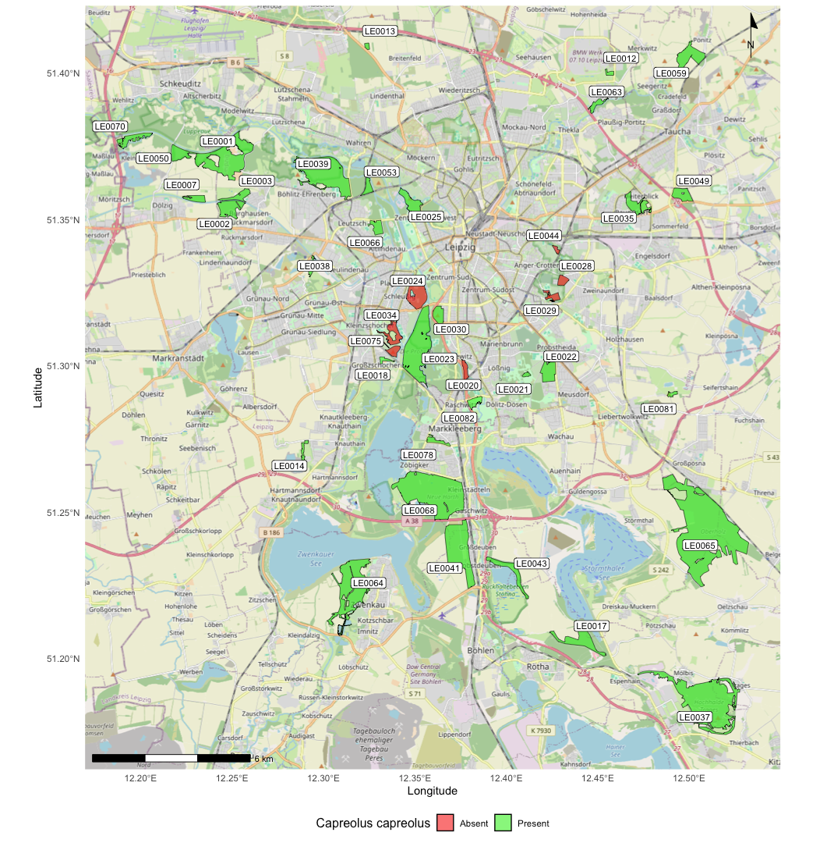

#### Map x: Presence-Absence Map of Martes (*Martes fiona* & *Martes martes*)

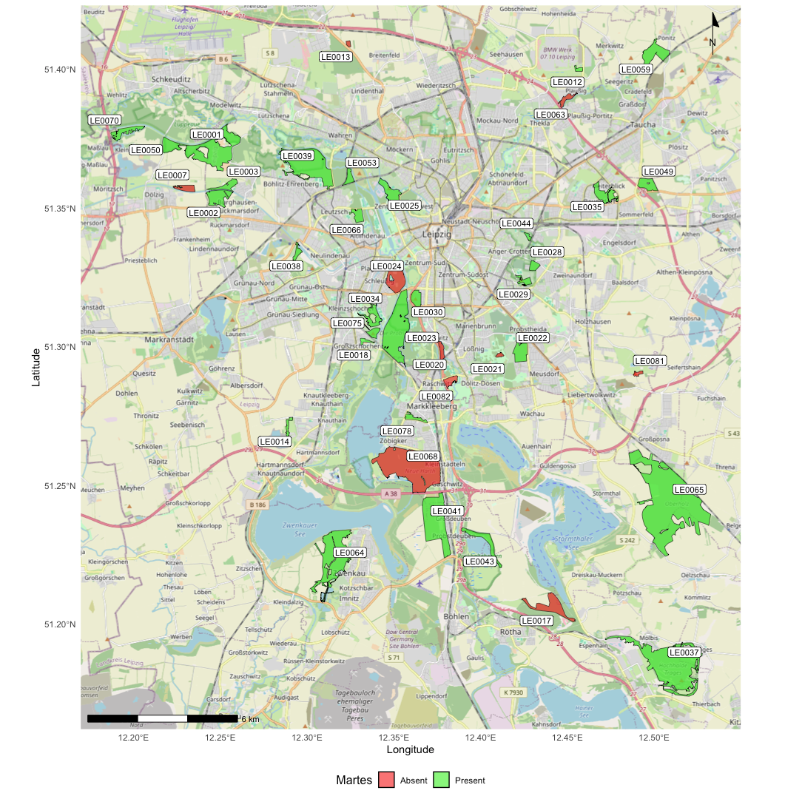

#### 

#### Map x: Presence-Absence Map of Badger (*Meles meles*)

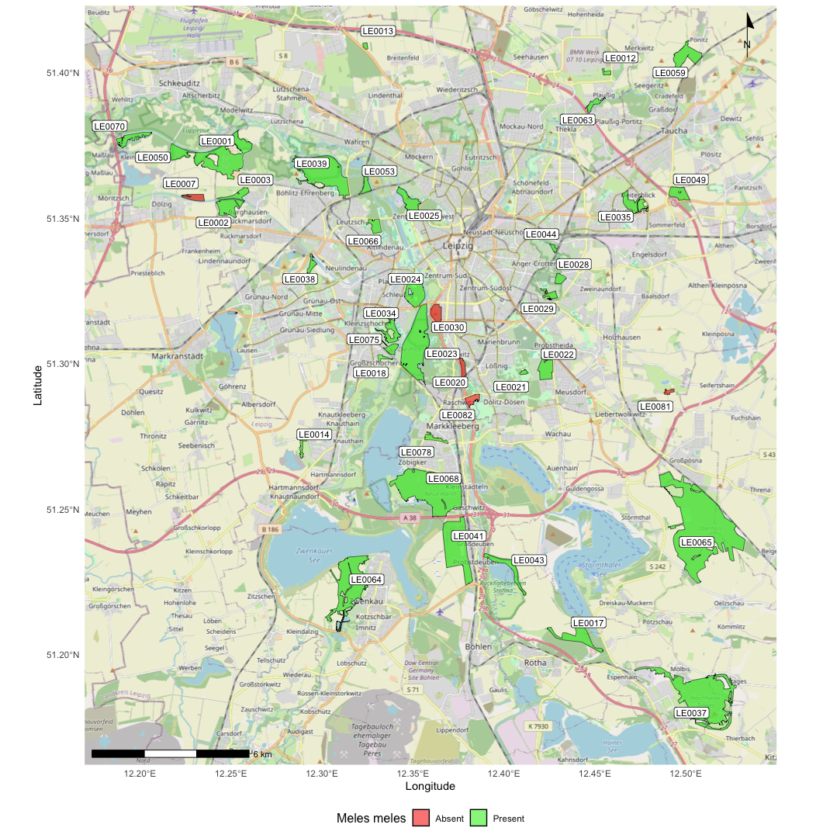

#### Map x: Presence-Absence Map of Wild Boar (*Sus Scrofa*)

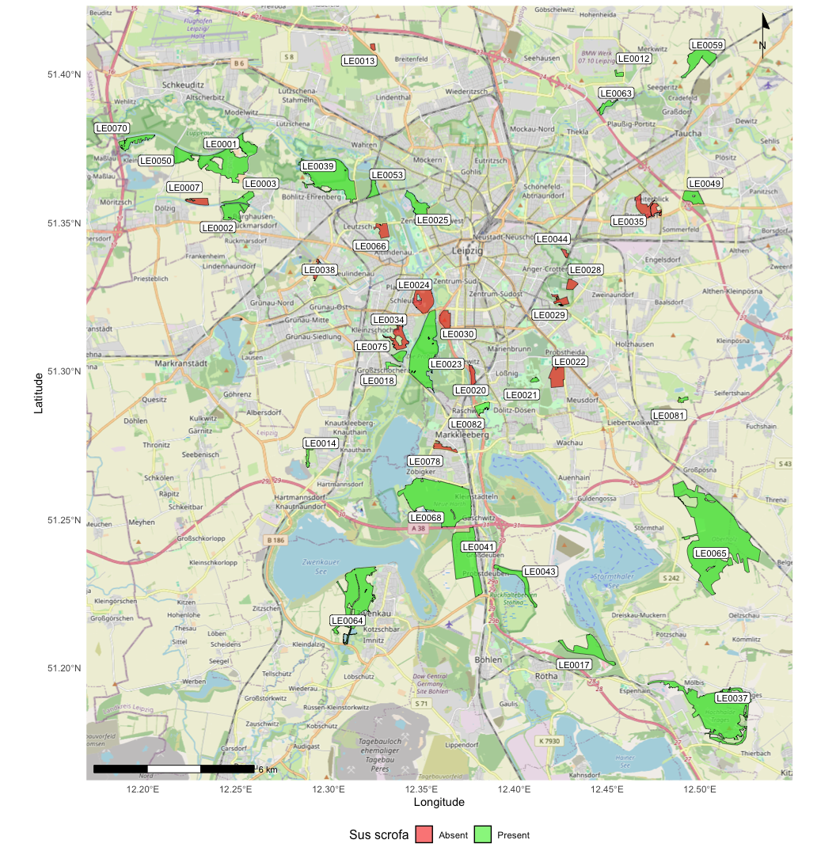

#### Map x: Presence-Absence Map of Wildcat (*Felis silvestris*)

#### Map x: Presence-Absence Map of Racoon (*Procyon lotor*)

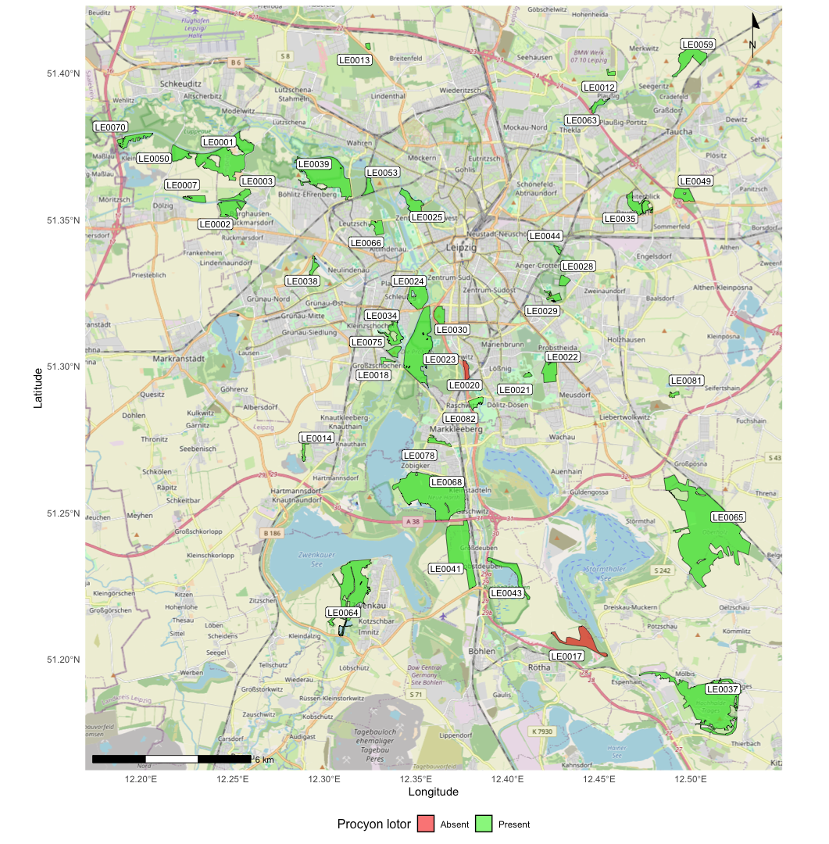

#### Map x: Presence-Absence Map of Red Fox (*Vulpes vulpes*)

# Discussion

SLOSS?

# Conclusion

# References

Arrhenius, O. (1921). Species and Area. *The Journal of Ecology*, *9*(1), 95. https://doi.org/10.2307/2255763

Barlow, J., Gardner, T. A., Araujo, I. S., Ávila-Pires, T. C., Bonaldo, A. B., Costa, J. E., Esposito, M. C., Ferreira, L. V., Hawes, J., Hernandez, M. I. M., Hoogmoed, M. S., Leite, R. N., Lo-Man-Hung, N. F., Malcolm, J. R., Martins, M. B., Mestre, L. A. M., Miranda-Santos, R., Nunes-Gutjahr, A. L., Overal, W. L., … Peres, C. A. (2007). Quantifying the biodiversity value of tropical primary, secondary, and plantation forests. *Proceedings of the National Academy of Sciences*, *104*(47), 18555–18560. https://doi.org/10.1073/pnas.0703333104

Bateman, P. W., & Fleming, P. A. (2012). Big city life: carnivores in urban environments. *Journal of Zoology*, *287*(1), 1–23. https://doi.org/10.1111/j.1469-7998.2011.00887.x

Blair, R. B. (1996). Land Use and Avian Species Diversity Along an Urban Gradient. *Ecological Applications*, *6*(2), 506–519. https://doi.org/10.2307/2269387

Carnus, J.-M., Parrotta, J., Brockerhoff, E., Arbez, M., Jactel, H., Kremer, A., Lamb, D., O’Hara, K., & Walters, B. (2006). Planted Forests and Biodiversity. *Journal of Forestry*, *104*(2), 65–77. https://doi.org/10.1093/jof/104.2.65

Casaer, J., Milotic, T., Liefting, Y., Desmet, P., & Jansen, P. (2019). *Agouti: A platform for processing and archiving camera-trap images*.

Czech, B., Krausman Paul R., & Devers, P. K. (2000). Economic Associations among Causes of Species Endangerment in the United States. *Biosience*, *50*(7), 593–601. https://doi.org/https://doi.org/10.1641/0006-3568(2000)050[0593:EAACOS]2.0.CO;2

Dengler, J. (2009). Which function describes the species–area relationship best? A review and empirical evaluation. *Journal of Biogeography*, *36*(4), 728–744. https://doi.org/10.1111/j.1365-2699.2008.02038.x

Fahrig, L. (2003). Effects of Habitat Fragmentation on Biodiversity. *Annual Review of Ecology, Evolution, and Systematics*, *34*(1), 487–515. https://doi.org/10.1146/annurev.ecolsys.34.011802.132419

Forman, R. T. T. (2014). *Urban Ecology*. Cambridge University Press. https://doi.org/10.1017/CBO9781139030472

Gaston, K. J. (2014). *Urban Ecology*. Cambridge University Press. https://www.cambridge.org/de/universitypress/subjects/life-sciences/ecology-and-conservation/urban-ecology?format=AR

Gerard, P. W., & Service, U. S. F. and W. (1995). Agricultural practices, farm policy, and the conservation of biological diversity. In *Biological Science Report*. https://pubs.usgs.gov/publication/bsr4

Grimm, N. B., Faeth, S. H., Golubiewski, N. E., Redman, C. L., Wu, J., Bai, X., & Briggs, J. M. (2008). Global Change and the Ecology of Cities. *Science*, *319*(5864), 756–760. https://doi.org/10.1126/science.1150195

Haddad, N. M., Brudvig, L. A., Clobert, J., Davies, K. F., Gonzalez, A., Holt, R. D., Lovejoy, T. E., Sexton, J. O., Austin, M. P., Collins, C. D., Cook, W. M., Damschen, E. I., Ewers, R. M., Foster, B. L., Jenkins, C. N., King, A. J., Laurance, W. F., Levey, D. J., Margules, C. R., … Townshend, J. R. (2015). Habitat fragmentation and its lasting impact on Earth’s ecosystems. *Science Advances*, *1*(2), e1500052. https://doi.org/10.1126/sciadv.1500052

Hanski, I. (2011). Habitat Loss, the Dynamics of Biodiversity, and a Perspective on Conservation. *AMBIO*, *40*(3), 248–255. https://doi.org/10.1007/s13280-011-0147-3

Hartley, M. J. (2002). Rationale and methods for conserving biodiversity in plantation forests. *Forest Ecology and Management*, *155*(1–3), 81–95. https://doi.org/10.1016/S0378-1127(01)00549-7

Hernandez, A., Miao, Z., Vargas, L., Dodhia, R., & Lavista Ferres, J. (2024). *Pytorch-Wildlife: A Collaborative Deep Learning Framework for Conservation*.

Hoffmann, M., Hilton-Taylor, C., Angulo, A., Böhm, M., Brooks, T. M., Butchart, S. H. M., Carpenter, K. E., Chanson, J., Collen, B., Cox, N. A., Darwall, W. R. T., Dulvy, N. K., Harrison, L. R., Katariya, V., Pollock, C. M., Quader, S., Richman, N. I., Rodrigues, A. S. L., Tognelli, M. F., … Stuart, S. N. (2010). The Impact of Conservation on the Status of the World’s Vertebrates. *Science*, *330*(6010), 1503–1509. https://doi.org/10.1126/science.1194442

Knorr, D., Khoo, C. S. H., & Augustin, M. A. (2018). Food for an Urban Planet: Challenges and Research Opportunities. *Frontiers in Nutrition*, *4*. https://doi.org/10.3389/fnut.2017.00073

Lacher, T. E., Davidson, A. D., Fleming, T. H., Gómez-Ruiz, E. P., McCracken, G. F., Owen-Smith, N., Peres, C. A., & Vander Wall, S. B. (2019). The functional roles of mammals in ecosystems. *Journal of Mammalogy*, *100*(3), 942–964. https://doi.org/10.1093/jmammal/gyy183

Laurance, W. F., Camargo, J. L. C., Fearnside, P. M., Lovejoy, T. E., Williamson, G. B., Mesquita, R. C. G., Meyer, C. F. J., Bobrowiec, P. E. D., & Laurance, S. G. W. (2018). An Amazonian rainforest and its fragments as a laboratory of global change. *Biological Reviews*, *93*(1), 223–247. https://doi.org/10.1111/brv.12343

Laurance, W. F., Camargo, J. L. C., Luizão, R. C. C., Laurance, S. G., Pimm, S. L., Bruna, E. M., Stouffer, P. C., Bruce Williamson, G., Benítez-Malvido, J., Vasconcelos, H. L., Van Houtan, K. S., Zartman, C. E., Boyle, S. A., Didham, R. K., Andrade, A., & Lovejoy, T. E. (2011). The fate of Amazonian forest fragments: A 32-year investigation. *Biological Conservation*, *144*(1), 56–67. https://doi.org/10.1016/j.biocon.2010.09.021

Laurance, W. F., Nascimento, H. E. M., Laurance, S. G., Andrade, A., Ewers, R. M., Harms, K. E., Luizão, R. C. C., & Ribeiro, J. E. (2007). Habitat Fragmentation, Variable Edge Effects, and the Landscape-Divergence Hypothesis. *PLoS ONE*, *2*(10), e1017. https://doi.org/10.1371/journal.pone.0001017

Liu, J., & Diamond, J. (2005). China’s environment in a globalizing world. *Nature*, *435*(7046), 1179–1186. https://doi.org/10.1038/4351179a

Lugo, A. E. (1997). The apparent paradox of reestablishing species richness on degraded lands with tree monocultures. *Forest Ecology and Management*, *99*(1–2), 9–19. https://doi.org/10.1016/S0378-1127(97)00191-6

Luniak, M. (2004). *Synurbization-adaptation of animal wildlife to urban development*. https://api.semanticscholar.org/CorpusID:16799520

Malhi, Y., Aragão, L. E. O. C., Galbraith, D., Huntingford, C., Fisher, R., Zelazowski, P., Sitch, S., McSweeney, C., & Meir, P. (2009). Exploring the likelihood and mechanism of a climate-change-induced dieback of the Amazon rainforest. *Proceedings of the National Academy of Sciences*, *106*(49), 20610–20615. https://doi.org/10.1073/pnas.0804619106

Malhi, Y., Doughty, C. E., Galetti, M., Smith, F. A., Svenning, J.-C., & Terborgh, J. W. (2016). Megafauna and ecosystem function from the Pleistocene to the Anthropocene. *Proceedings of the National Academy of Sciences*, *113*(4), 838–846. https://doi.org/10.1073/pnas.1502540113

Margules, C. R., & Pressey, R. L. (2000). Systematic conservation planning. *Nature*, *405*(6783), 243–253. https://doi.org/10.1038/35012251

McKinney, M. L. (2002). Urbanization, Biodiversity, and Conservation: The impacts of urbanization on native species are poorly studied, but educating a highly urbanized human population about these impacts can greatly improve species conservation in all ecosystems. *BioScience*, *52*(10), 883–890. https://doi.org/10.1641/0006-3568(2002)052[0883:UBAC]2.0.CO;2

McKinney, M. L. (2006). Urbanization as a major cause of biotic homogenization. *Biological Conservation*, *127*(3), 247–260. https://doi.org/10.1016/j.biocon.2005.09.005

Miller, J. R. (2005). Biodiversity conservation and the extinction of experience. *Trends in Ecology & Evolution*, *20*(8), 430–434. https://doi.org/https://doi.org/10.1016/j.tree.2005.05.013

Mulwa, R. K., Böhning‐Gaese, K., & Schleuning, M. (2012). High Bird Species Diversity in Structurally Heterogeneous Farmland in Western Kenya. *Biotropica*, *44*(6), 801–809. https://doi.org/10.1111/j.1744-7429.2012.00877.x

Newport, J., Shorthouse, D. J., & Manning, A. D. (2014). The effects of light and noise from urban development on biodiversity: Implications for protected areas in Australia. *Ecological Management & Restoration*, *15*(3), 204–214. https://doi.org/10.1111/emr.12120

Pickett, S. T. A., Cadenasso, M. L., Grove, J. M., Nilon, C. H., Pouyat, R. V., Zipperer, W. C., & Costanza, R. (2001). Urban Ecological Systems: Linking Terrestrial Ecological, Physical, and Socioeconomic Components of Metropolitan Areas. *Annual Review of Ecology and Systematics*, *32*(1), 127–157. https://doi.org/10.1146/annurev.ecolsys.32.081501.114012

Pillay, R., Venter, M., Aragon‐Osejo, J., González‐del‐Pliego, P., Hansen, A. J., Watson, J. E., & Venter, O. (2022). Tropical forests are home to over half of the world’s vertebrate species. *Frontiers in Ecology and the Environment*, *20*(1), 10–15. https://doi.org/10.1002/fee.2420

Piola, R. F., & Johnston, E. L. (2008). Pollution reduces native diversity and increases invader dominance in marine hard‐substrate communities. *Diversity and Distributions*, *14*(2), 329–342. https://doi.org/10.1111/j.1472-4642.2007.00430.x

Ramesh, T., Kalle, R., & Downs, C. T. (2016). Predictors of mammal species richness in KwaZulu-Natal, South Africa. *Ecological Indicators*, *60*, 385–393. https://doi.org/10.1016/j.ecolind.2015.07.011

Reed, D. H. (2004). Extinction risk in fragmented habitats. In *Animal Conservation* (Vol. 7, Issue 2, pp. 181–191). https://doi.org/10.1017/S1367943004001313

Riley, S. P. D., Sauvajot, R. M., Fuller, T. K., York, E. C., Kamradt, D. A., Bromley, C., & Wayne, R. K. (2003). Effects of urbanization and habitat fragmentation on bobcats and coyotes in southern California. *Conservation Biology*, *17*(2), 566–576. https://doi.org/10.1046/j.1523-1739.2003.01458.x

Ripple, W. J., Newsome, T. M., Wolf, C., Dirzo, R., Everatt, K. T., Galetti, M., Hayward, M. W., Kerley, G. I. H., Levi, T., Lindsey, P. A., Macdonald, D. W., Malhi, Y., Painter, L. E., Sandom, C. J., Terborgh, J., & Van Valkenburgh, B. (2015). Collapse of the world’s largest herbivores. *Science Advances*, *1*(4). https://doi.org/10.1126/sciadv.1400103

Rosenzweig, M. L. (1995). *Species Diversity in Space and Time*. Cambridge University Press. https://doi.org/10.1017/CBO9780511623387

Sinclair, A. R. E. (2003). Mammal population regulation, keystone processes and ecosystem dynamics. *Philosophical Transactions of the Royal Society of London. Series B: Biological Sciences*, *358*(1438), 1729–1740. https://doi.org/10.1098/rstb.2003.1359

Taubert, F., Fischer, R., Groeneveld, J., Lehmann, S., Müller, M. S., Rödig, E., Wiegand, T., & Huth, A. (2018). Global patterns of tropical forest fragmentation. *Nature*, *554*(7693), 519–522. https://doi.org/10.1038/nature25508

van Vuuren, D. P., Sala, O. E., & Pereira, H. M. (2006). The Future of Vascular Plant Diversity Under Four Global Scenarios. *Ecology and Society*, *11*(2), art25. https://doi.org/10.5751/ES-01818-110225

Bassi, S., Howard, R., & Geneletti, D. (2008). Assessing the impacts of land-use change on ecosystem services: A framework for case studies. International Journal of Biodiversity Science & Management, 4(1), 44-55.

Betts, M. G., Hadley, A. S., Frey, D. W., Frey, S. J., Gannon, J., Harris, S. H., ... & Kormann, U. G. (2017). A species-centered approach to modeling habitat fragmentation effects. Ecography, 40(8), 1016-1030.

Blair, R. B. (1996). Land use and avian species diversity along an urban gradient. Ecological Applications, 6(2), 506-519.

FAO & UNEP. (2020). The State of the World’s Forests 2020. Forests, biodiversity and people. Rome.

Fischer, J., & Lindenmayer, D. B. (2007). Landscape modification and habitat fragmentation: a synthesis. Global Ecology and Biogeography, 16(3), 265-280.

Grimm, N. B., Faeth, S. H., Golubiewski, N. E., Redman, C. L., Wu, J., Bai, X., & Briggs, J. M. (2008). Global change and the ecology of cities. Science, 319(5864), 756-760.

IUCN & UNEP-WCMC. (2016). The World Database on Protected Areas (WDPA). UNEP-WCMC and IUCN.

Rodrigues, A. S., Andelman, S. J., Bakarr, M. I., Boitani, L., Brooks, T. M., Cowling, R. M., ... & Yan, X. (2004). Effectiveness of the global protected area network in representing species diversity. Nature, 428(6983), 640-643.

Rovero, F., Zimmermann, F., Berzi, D., & Meek, P. (2013). "Which camera trap type and how many do I need?" A review of camera features and study designs for a range of wildlife research applications. Hystrix, the Italian Journal of Mammalogy, 24(2), 148-156.

Secretariat of the Convention on Biological Diversity. (2010). Global Biodiversity Outlook 3. Montreal: Secretariat of the Convention on Biological Diversity.

Shvidenko, A., Barber, C. V., Persson, R., Gonzalez, P., Hassan, R., Lakyda, I., ... & Rozhkov, V. (2005). Forest and woodland systems. Millennium Ecosystem Assessment: Current State and Trends, 585-621.

Turner, I. M. (1996). Species loss in fragments of tropical rain forest: a review of the evidence. Journal of Applied Ecology, 33(2), 200-209.

United Nations. (2014). World Urbanization Prospects: The 2014 Revision, Highlights (ST/ESA/SER.A/352). Department of Economic and Social Affairs, Population Division, United Nations.

Vie, J. C., Hilton-Taylor, C., & Stuart, S. N. (2009). Wildlife in a changing world: an analysis of the 2008 IUCN Red List of Threatened Species. Gland, Switzerland: IUCN.

## Eidesstattliche Erklärung

Auch für den Fall, dass Sie Ihre Abschlussarbeit in englischer Sprache anfertigen sollten, ist die Eidesstattliche Erklärung in deutscher Sprache abzugeben (ggf. zusätzlich zur englischsprachigen) - die prüfungsrelevante Amtssprache ist Deutsch.

Auch wenn es keine feststehende Formulierung gibt, so müssen die Selbständigkeitserklärung und die

Erklärung über Quellen sowie die Erklärung, dass die Arbeit noch nicht an anderer Stelle eingereicht wurde, enthalten sein. Ein Beispiel:

Hiermit versichere ich, dass ich die vorliegende Arbeit selbstständig, ohne unzulässige fremde Hilfe und unter Beachtung der allgemeinen Grundsätze guter wissenschaftlicher Praxis verfasst und keine anderen als die von mir angegebenen Werke und/oder Hilfsmittel benutzt habe. Die Stellen der Arbeit, die anderen Werken dem Wortlaut oder dem Sinne nach entnommen sind, wurden in jedem Fal unter Angabe der Quellen (einschließlich des World Wide Web und anderer elektronischer Text- und Datensammlungen) kenntlich gemacht. Dies gilt auch für Zeichnungen, bildliche Darstellungen, Skizzen und dergleichen. Von anderen zur Verfügung gestellte Materialen oder Daten wurden als solche kenntlich gemacht. *

Mir ist bewusst, dass wahrheitswidrige Angaben als Täuschungsversuch behandelt werden und dass bei einem Täuschungsverdacht sämtliche Verfahren der Plagiatserkennung angewendet werden können.

Diese Arbeit wurde in gleicher oder ähnlicher Form noch nicht von mir bei einer anderen Prüfungsbehörde vorgelegt.

Ort/Datum +Unterschrift

* Dieser Teil kann ggf. noch mit einem Verweis bspw. auf „Materialien und Methoden" detaillierter ausgeführt werden.

# Appendix

## Appendix X

### Bescheinigung über das Nicht-Bestehen von Verbindlichkeiten

Bescheinigung

Name, Vorname: ____________________________________________________________________

Matrikelnummer: ___________________________________________________________________

**Es bestehen keine Verbindlichkeiten gegenüber der ULB-Zweigbibliothek.**

……………………………………………………………..……………………………………………………………..……………………………

Datum/Unterschrift ULB (bspw. Zweigstelle v.-Danckelmann-Platz)

**Nur bei internen Arbeiten: Es bestehen keine Verbindlichkeiten gegenüber dem Institutsbereich für**

……………………………………………………………..……………………………………………………………..……………………………

……………………………………………………………..……………………………………………………………..……………………………

Stempel / Datum / Unterschrift des Betreuers der Abschlussarbeit

*Die Ausgabe des Zeugnisses durch das Prüfungsamt erfolgt nur gegen Vorlage dieser Bescheinigung!*

# Digital Appedix

Pyton-Codes Megadetector

Images?

All R-Scripts used fully commented

Data